Sales Order Creation
Step 1
- Enter the T Code- VA01 in Command Bar
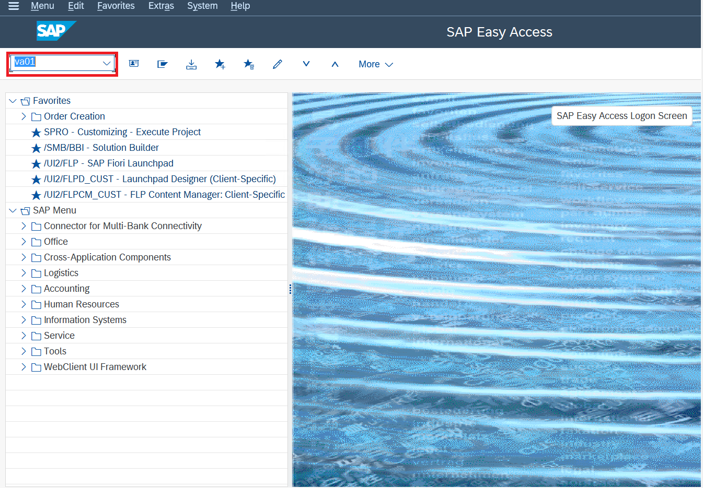
- Hit Enter

Step 2
- Enter Order Document Type (OR)
- Under Organisation Data, enter Sales Area ( Sales Org+Distribution Channel+Division)

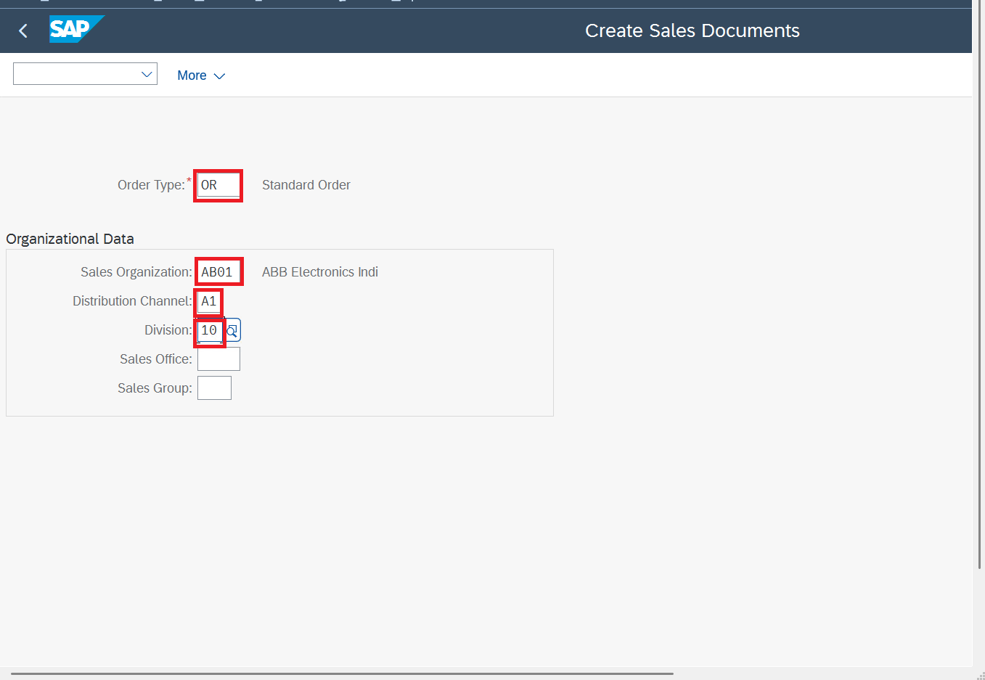

Step 3
- Enter Sold to Party (BP Created by You)
- Enter Customer Reference such as ( Test 1)
- Enter Material Created by You
- Enter Order Quantity
- Hit Enter
- Then click on Header Icon as highlighted
Header Icon

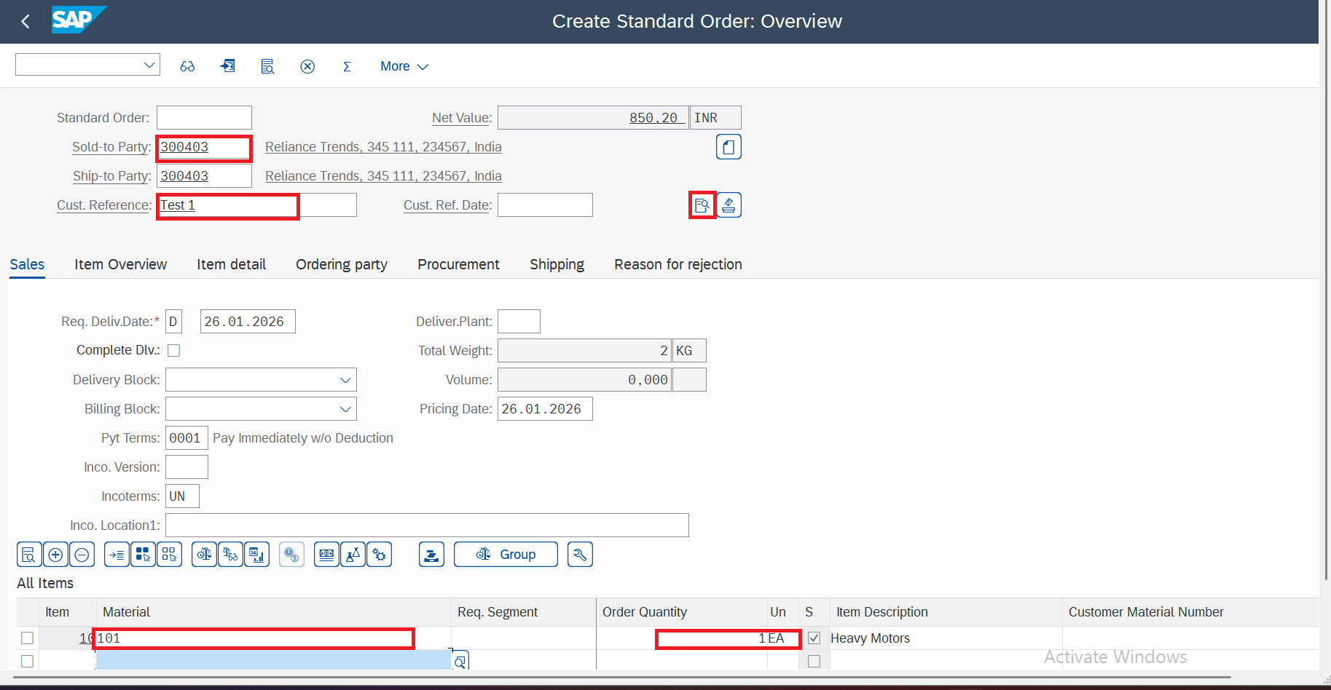

Step 4
- At Header level check few details captured by system.
- Order Type, Sales Area
- Pricing Procedure as highlighted
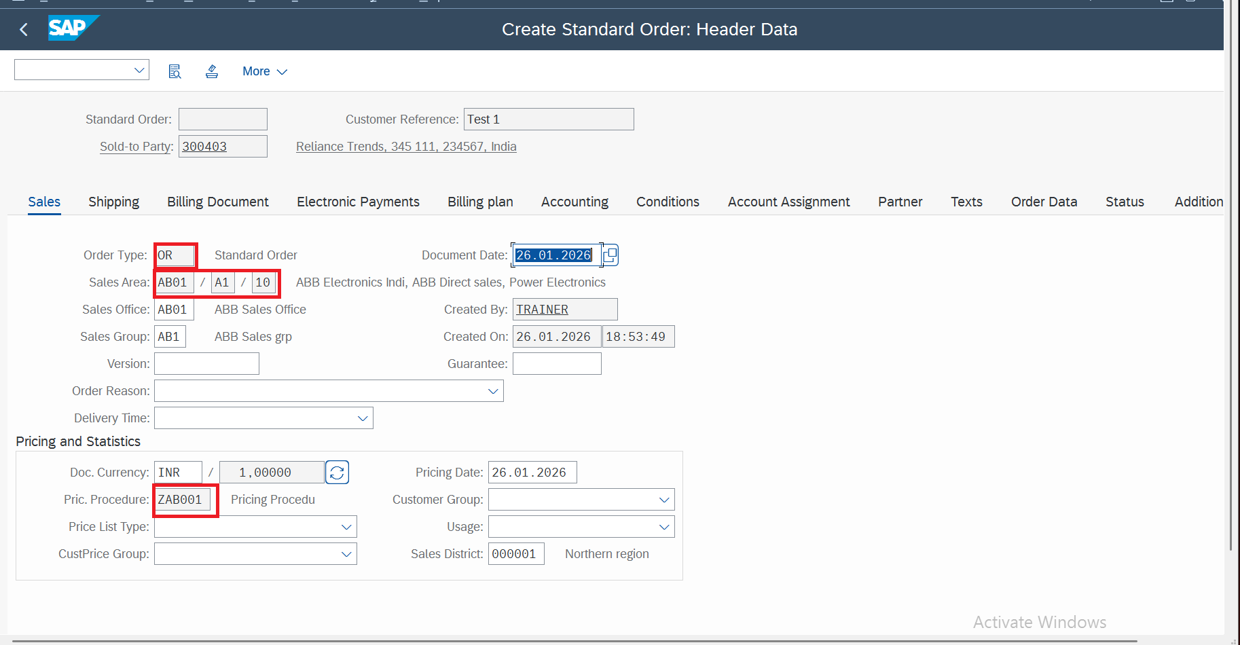

Step 5
- Double click on line Item
- Go to Condition Tab
- Check Conditions type determined by system

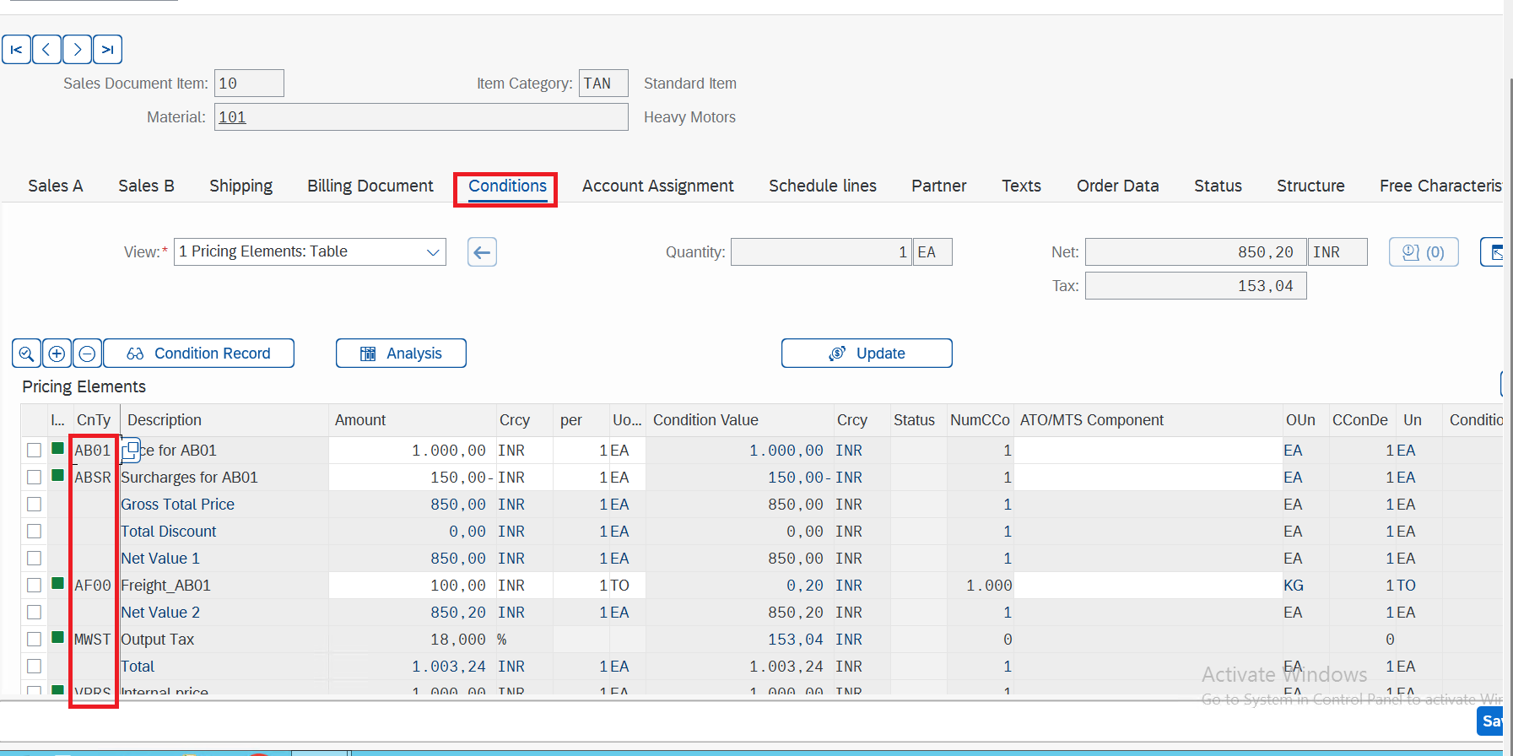

Step 6
- Click on Edit
- Check Incompletion log
- Document is complete , observe system message

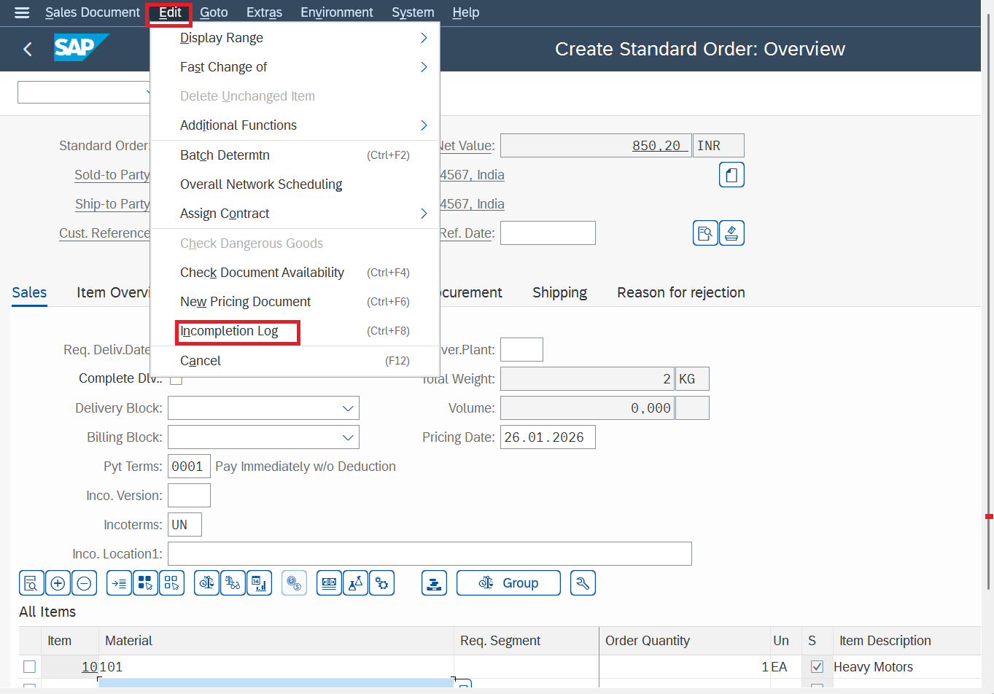

Step 7
- Click on Save Icon

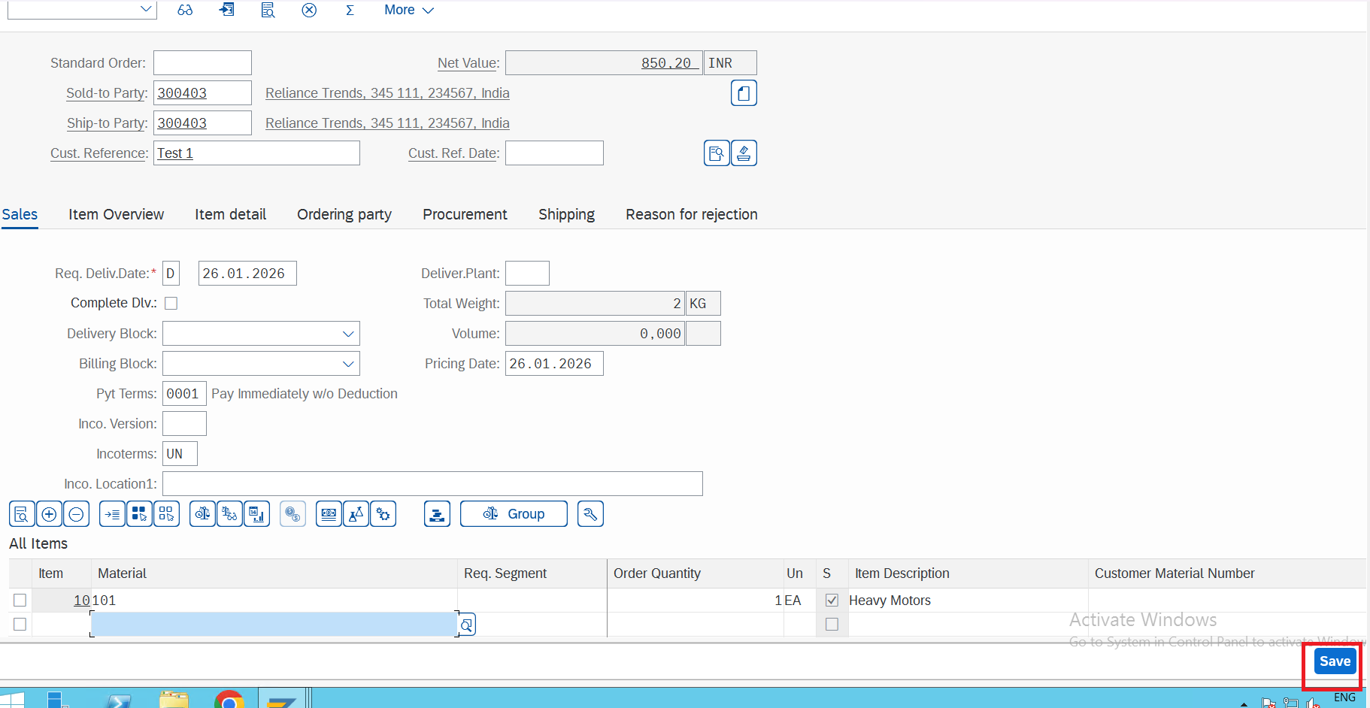

Step 8
- Sales Order gets created . Every Sales Order will have own number.
